SQL BASICS FOR DATA SCİENCE
(Based on SQLite)

Some additional sources:

SQL: What Is It? (liveabout.com)

What is SQL, how does it work and how is it being used (ntchosting.com)

SQLite Tutorial (tutorialspoint.com)

SQL vs. NoSQL - Know the Difference - Dataconomy

SQL Authority with Pinal Dave - SQL Server Performance Tuning Expert

SQL Puzzle Archives - SQL Authority with Pinal Dave

SQLZOO (For practice)

Entity Relationship (ER) Diagrams ile ilgili kaynaklar:

Entity-Relationship Diagrams - YouTube

Star Schema vs. Snowflake Schema | Vertabelo Database Modeler

Data Modeling 101 (agiledata.org)

What is Data Modeling | Introduction for Business Analysts (business-analysis-excellence.com)

SQL for Python

python-sql · PyPI

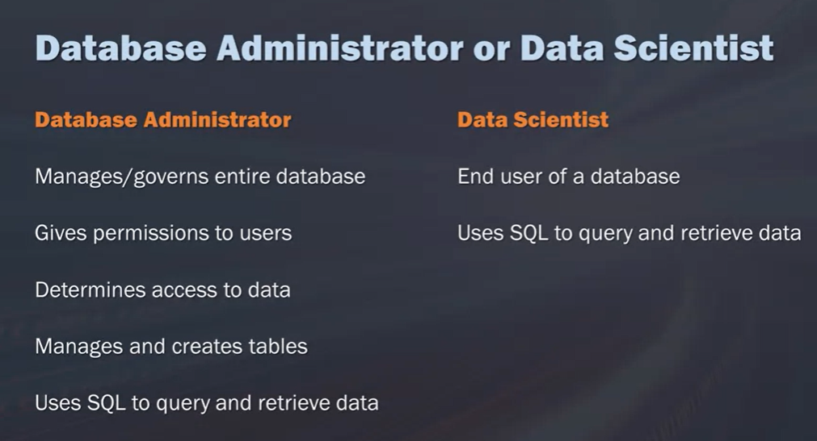

***

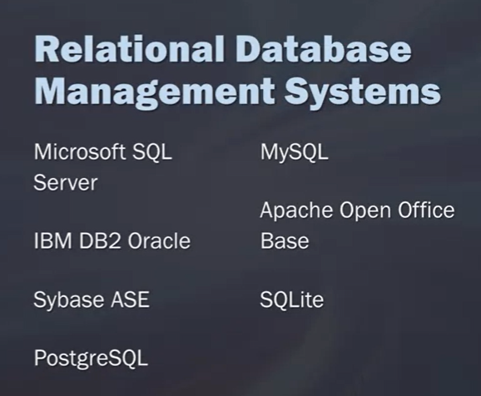

A database is really a container that is usually a file or cset of files and is used to organize and store all of the data. If you think of this in real world terms, It'd be like a filing system that has many cabinets along a wall. Within that system, within a database, we have tables, these tables are structured lists of data elements or specific data type. Going back to our analogy, you can think of this as maybe one of the cabinets within a whole wall of cabinets. Then if we dive further into the cabinet, into a table, what we find is we have columns and rows, which of course is what makes up a table.

Evolution of Data Models

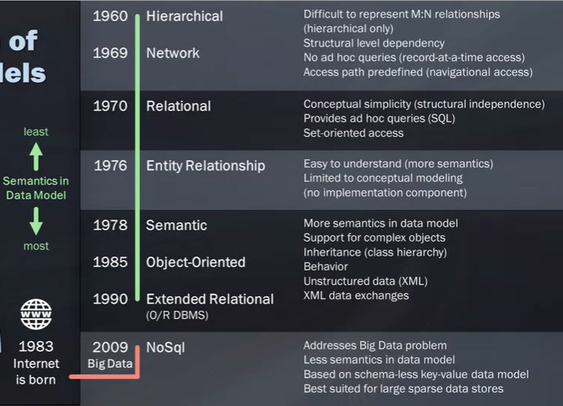

***
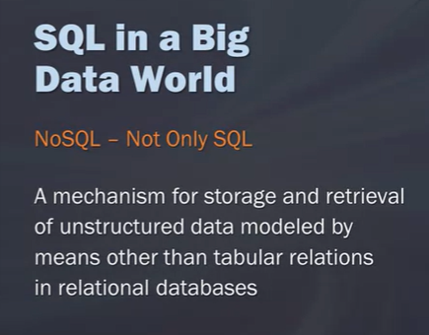

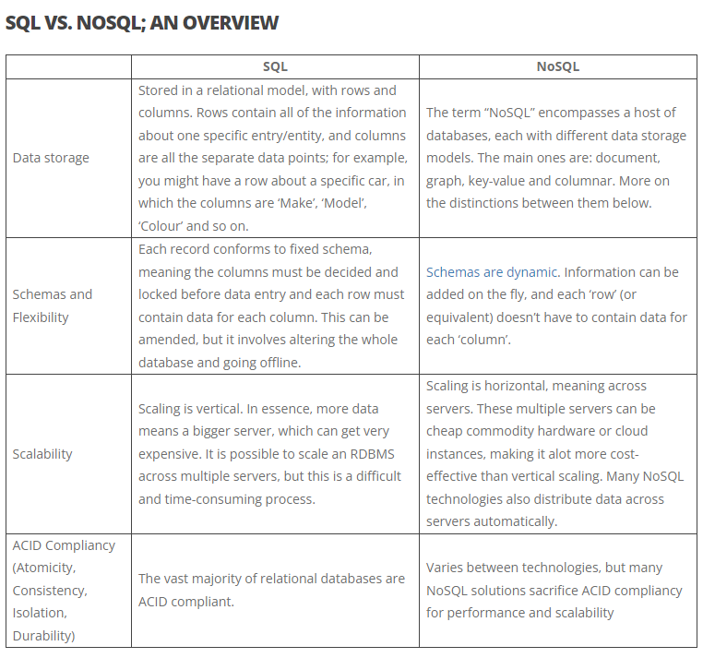

***

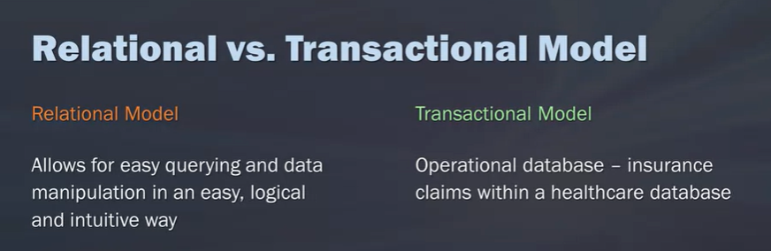

***
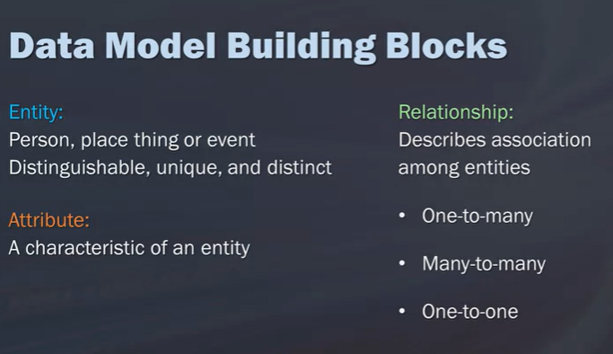

There are a few types of relationships in a database and the ones I want to cover are the three shown here: one-to-many, many-to-many and one-to-one. If you think of a one-to-many relationship,
this could be one customer that has many invoices. When you think of a many-to-many relationship,
this could be an example of many students to many classes. You may have one student who belongs to lots of different classes or you may have a class who has many different students. Then, if you think of a one-to-one relationship, this is a manager to a store. Let's say you have a sporting goods store and each of those stores has only one manager. That would be one example of a one-to-one relationship.

To understand these relationships between the tables a lot better, what's often used to depict this are ER diagrams. An ER model then is composed of the entity types and the specific relationships that can exist between these entities. These are usually displayed in a visual format and a relate represents a relationship between the tables. It often helps you to understand and represent a business process and it will show the links between these tables.

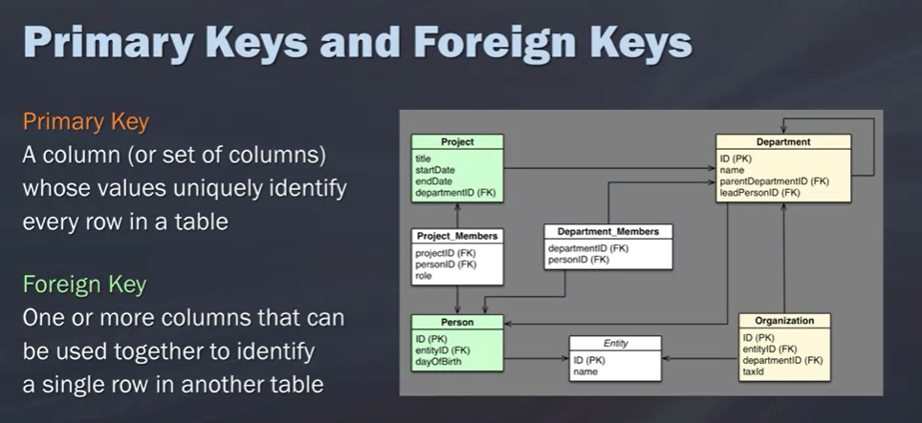

***

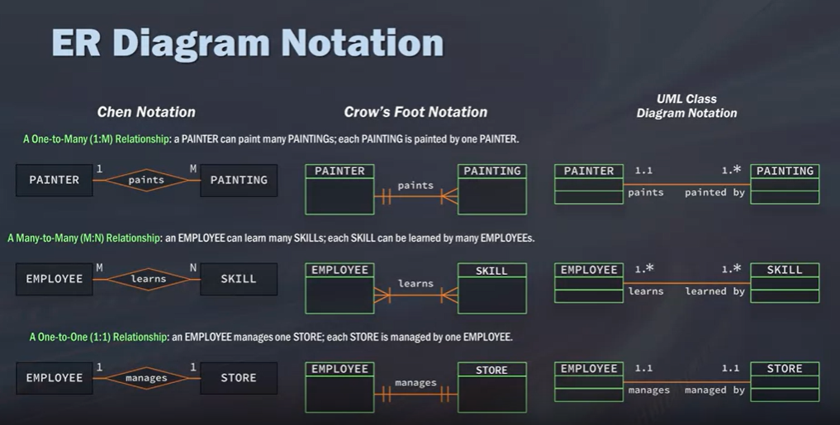
***
SELECT...FROM

Hangi tablodan hangi sütunların seçileceğini yazıyoruz. Eğer tüm kolonları seçeceksek SELECT * FROM ile yazıyoruz.

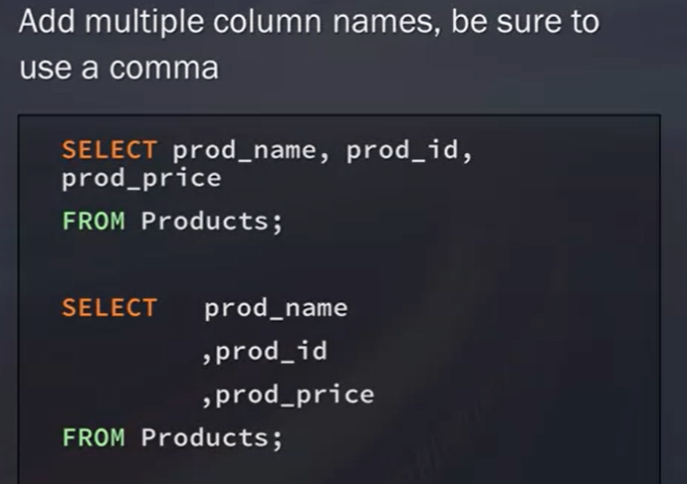
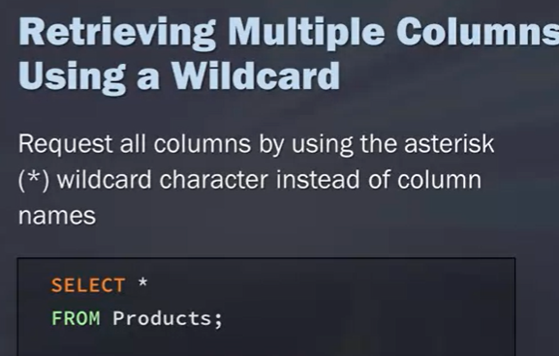
LIMIT: to limit the records (rows)
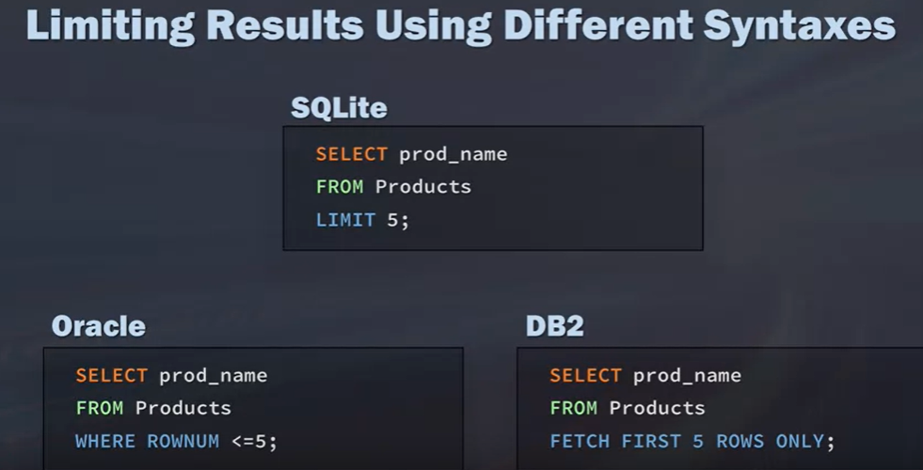

CREATING TABLES

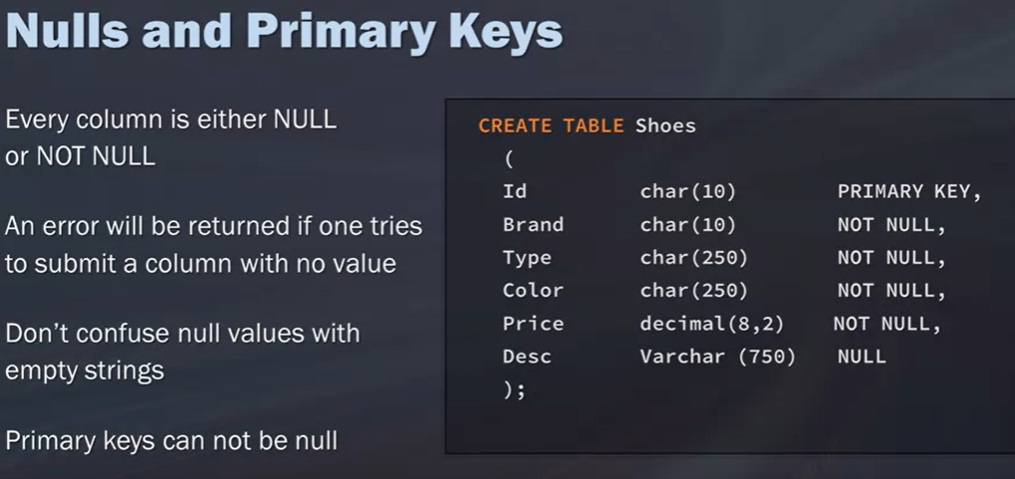

Primary Keys mast have a value.

ADDING DATA TO THE TABLE: Yeni değerleri INSERT INTO ile ve sütun sıralarını dikkate alarak VALUES kodu ile ekliyoruz (Id, Brand…). Kolon isimlerini yazarak da ekleyebiliriz.

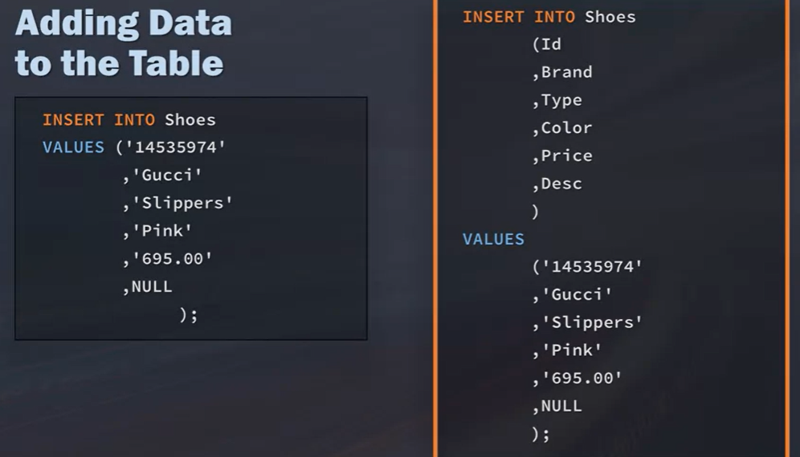

TEMPORARY TABLE
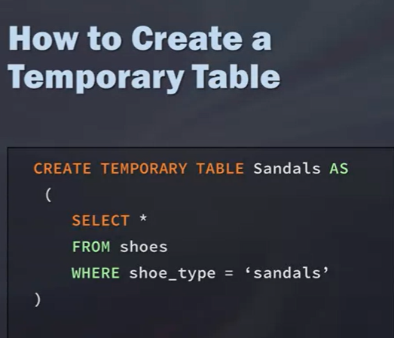

ADDING COMMENT

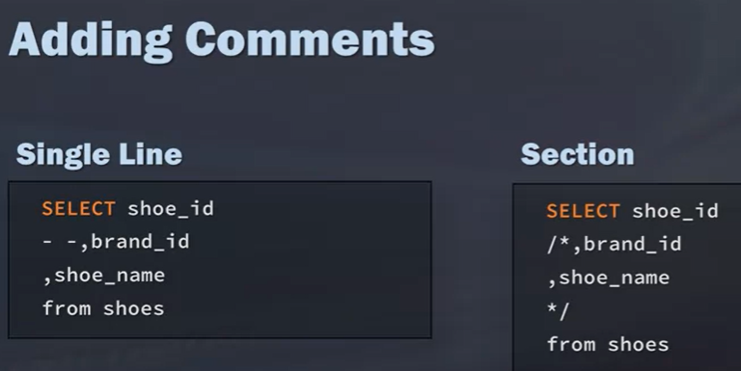

****

Filtering, Sorting, and Calculating Data with SQL
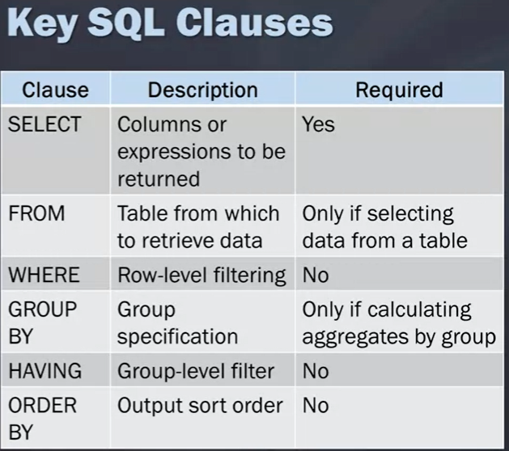

Filtering with WHERE
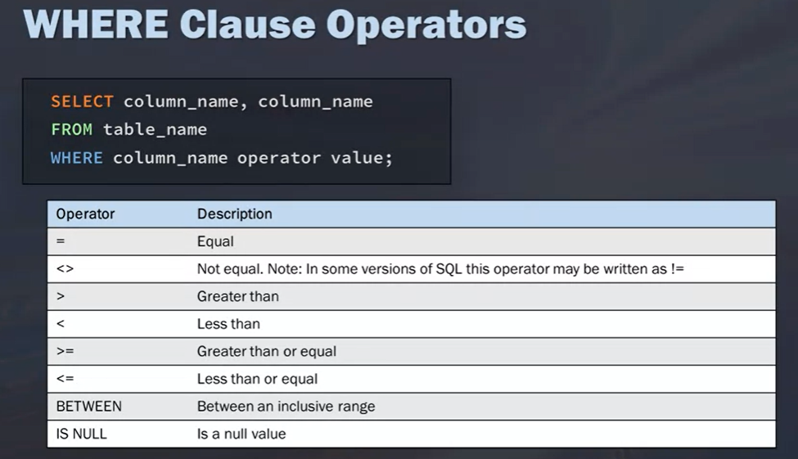

***
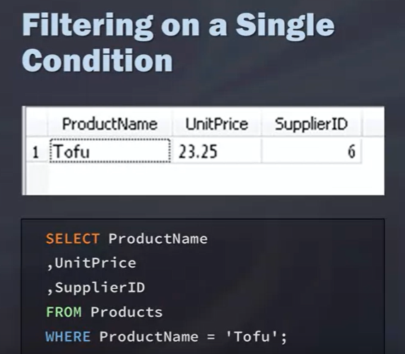
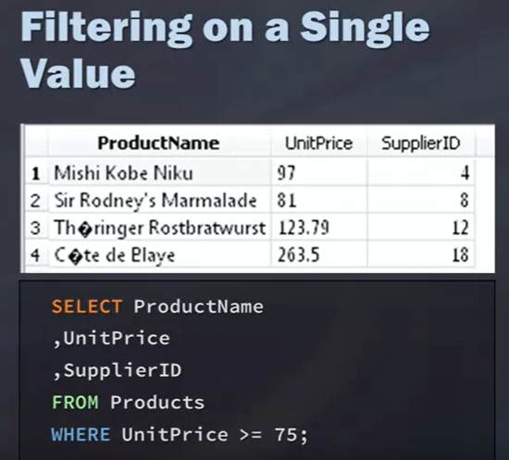

***Eşit değil ya da except anlamında arama yaparken...

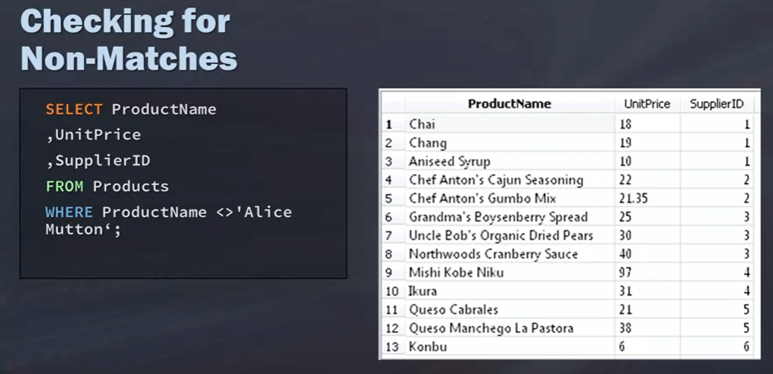

***BETWEEN AND ile bellibir aralıktaki değerlere de bakabiliriz.

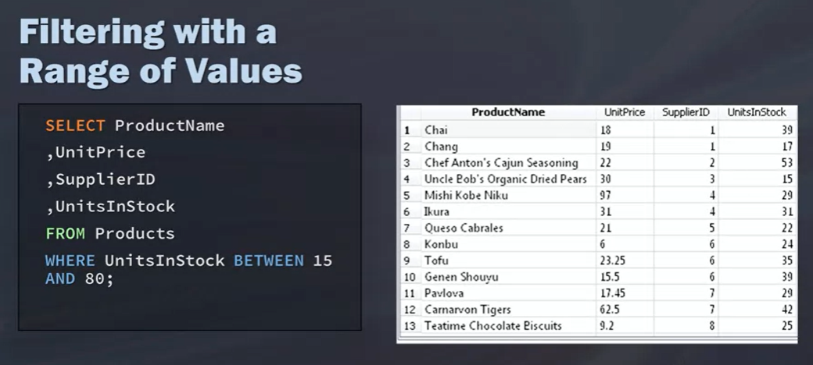

***Null value’ları görmek istersek...

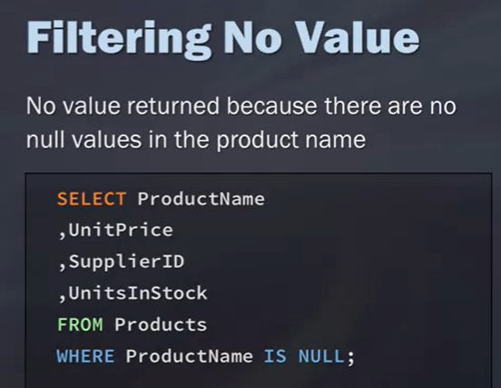

Filtering with IN, OR and NOT

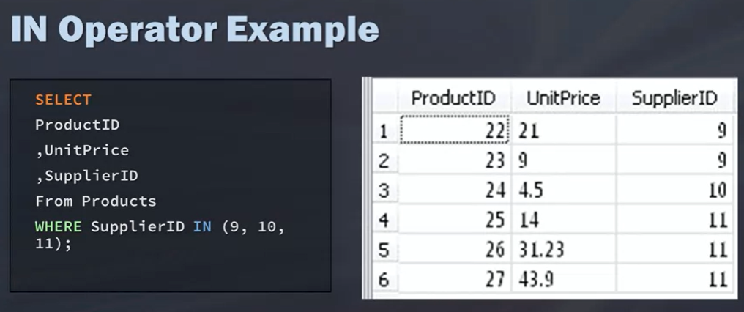

Bu örnekte BETWEEN AND şeklinde bir range tanımlanmadı çünü spesific bir değer aranıyor. Iki komut bazen aynı yerde kullanılabilse de farklılıkları var. Ayrıca IN () şeklinde parantez ile kullanılıyor.

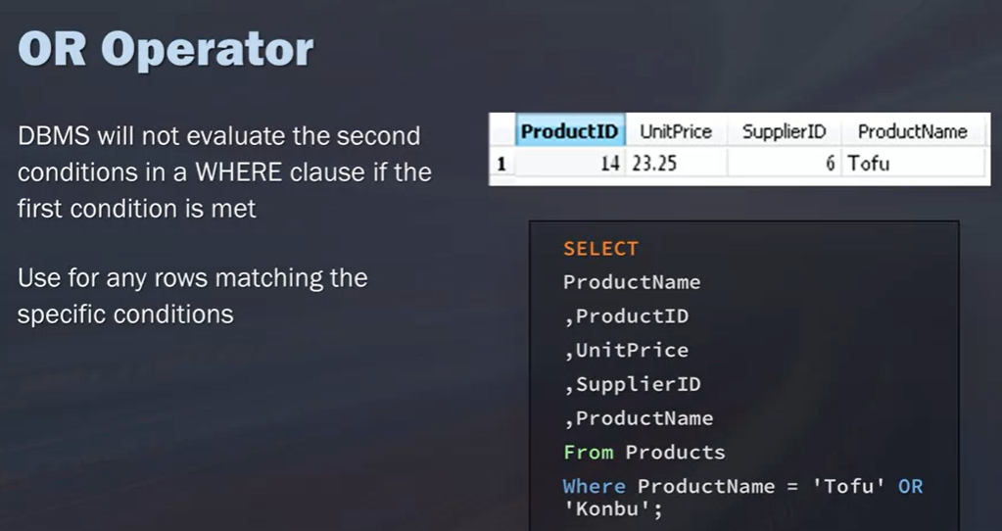

OR kullanınca iki durumu da saplayan recordları getirmiyor. Biri sağlandıysa yetiyor. Yukarıdakinde 1 ProductName select içinde fazladan yazılmış galiba.

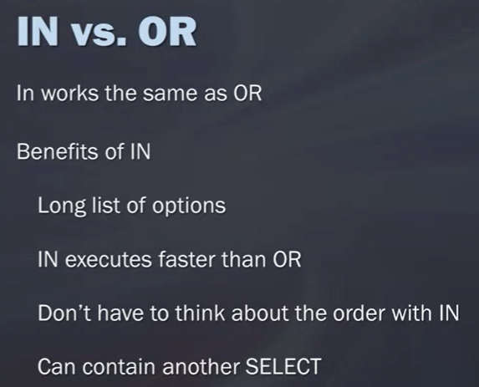

OR ve AND beraber kullanılırsa...
Aşağıdaki örnekteki sıralamda SQL OR komutuna öncelik verdiğinden dolayı iki sütundaki şartları sağlayan sonuç çıkmadı. Yani UnitPrice’ı 15’ten küçük olan değer var hala. İkinic örnekte OR paranteze alınınca Or ve AND ile yazılan şartları sağlayan sonucu elde ettik.

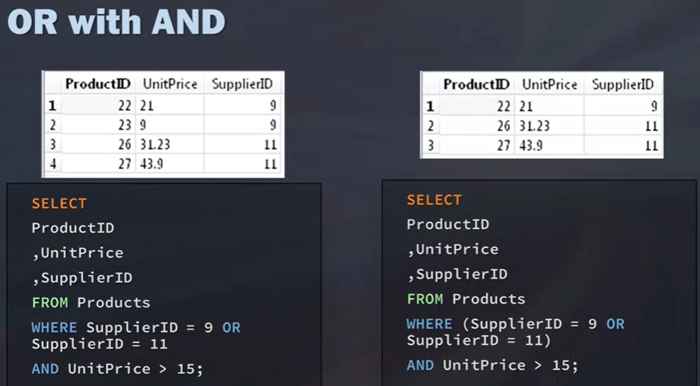

***
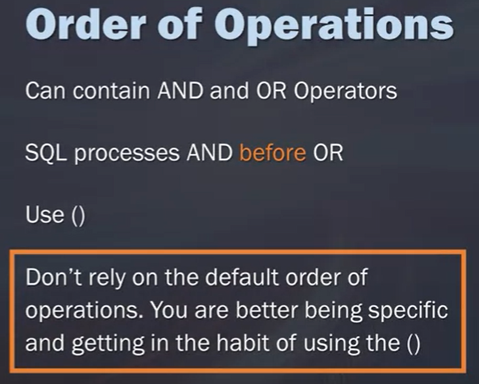

NOT operator’ü ile de istediğimizi dışarıda tutup diğerlerini çağırabiliriz. Aşağıdaki örnekte City değeri London ve Seattle olmayanları çağırdık.

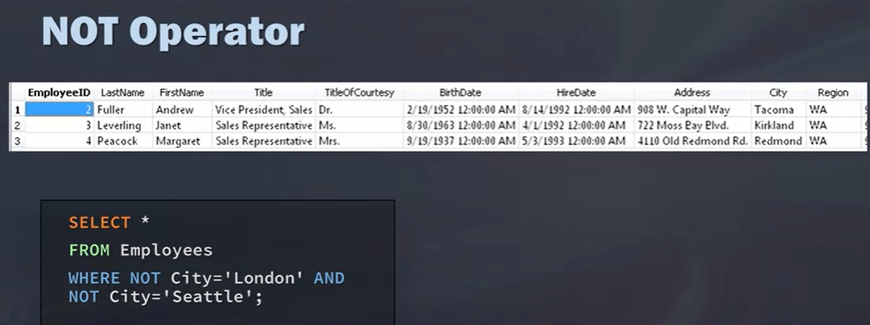

Using Wildcards
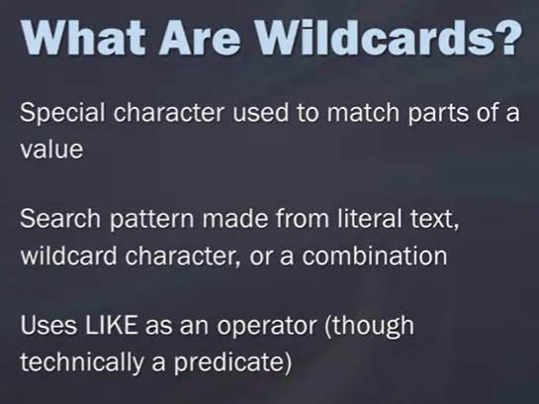
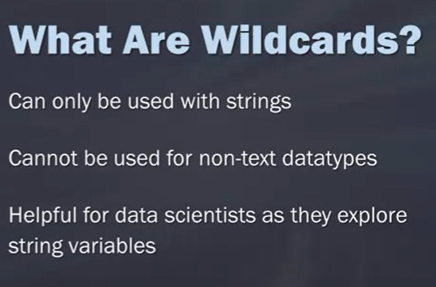

***
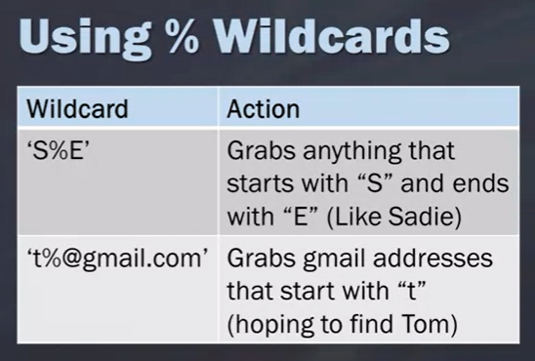
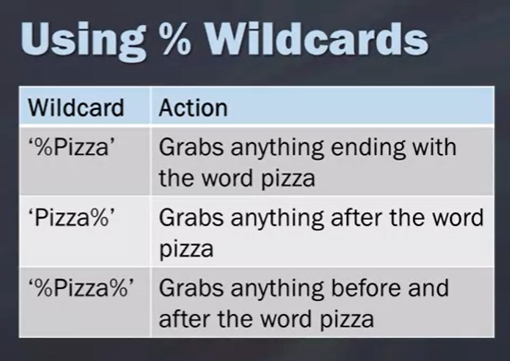

***
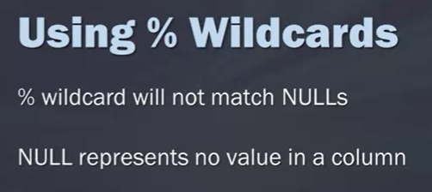

***
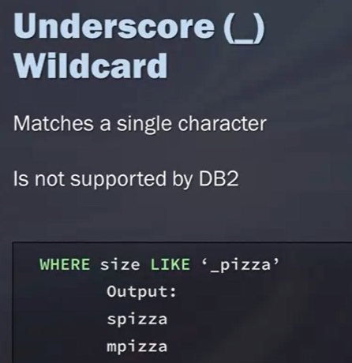
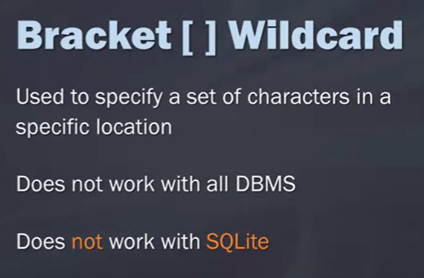

***
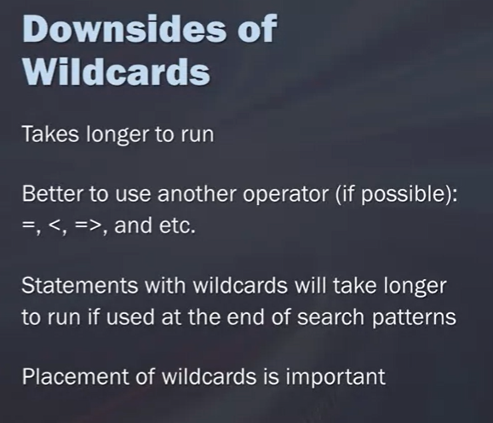

***
Sorting with ORDER BY

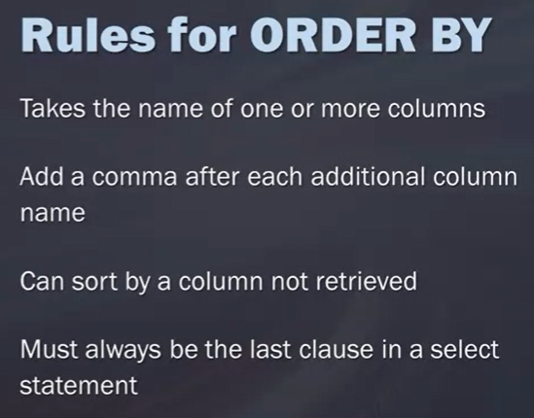
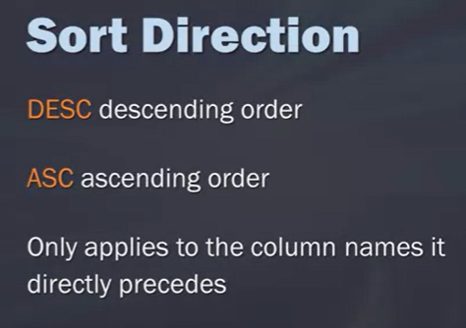

Math Operations
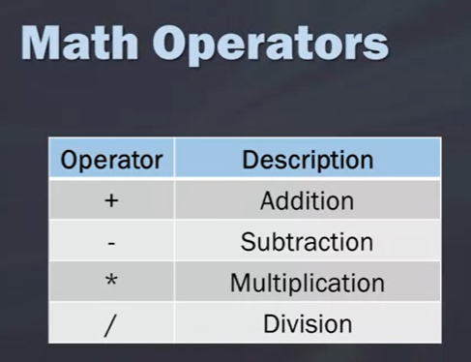
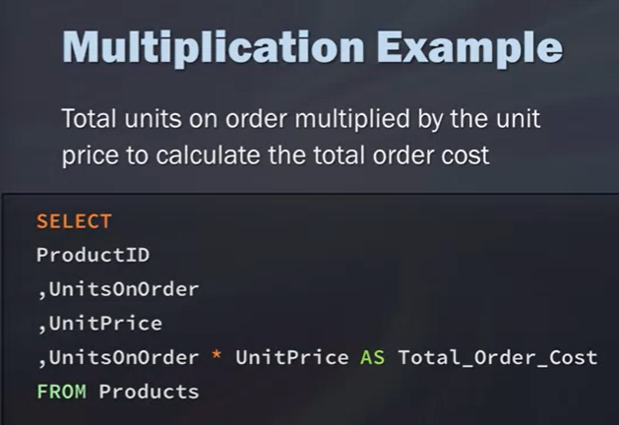

***
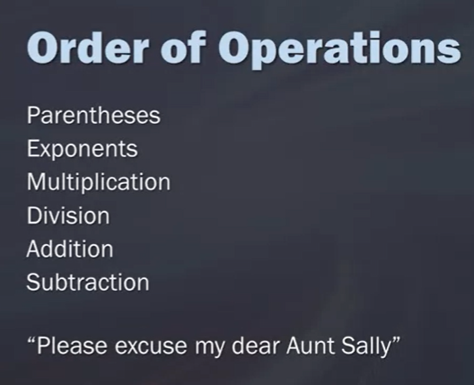
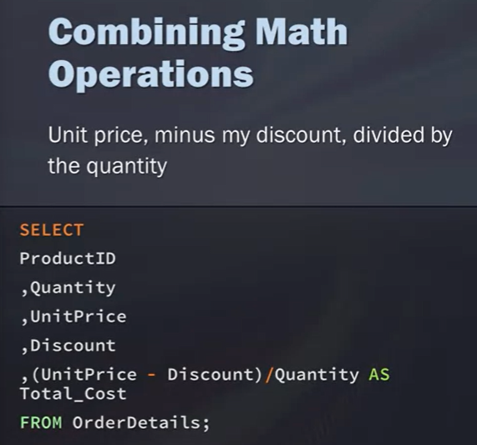

Aggregate Functions (AVERAGE, COUNT, MIN, MAX, SUM)

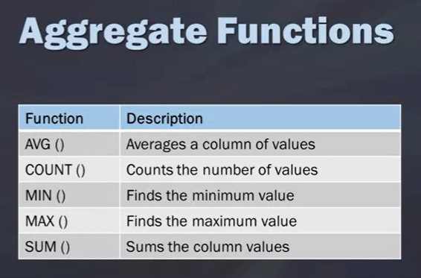

***
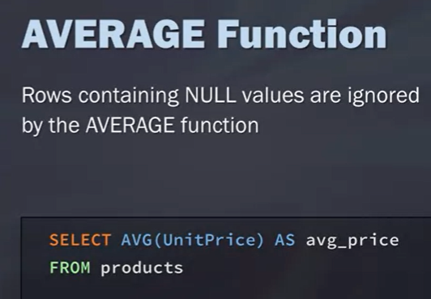
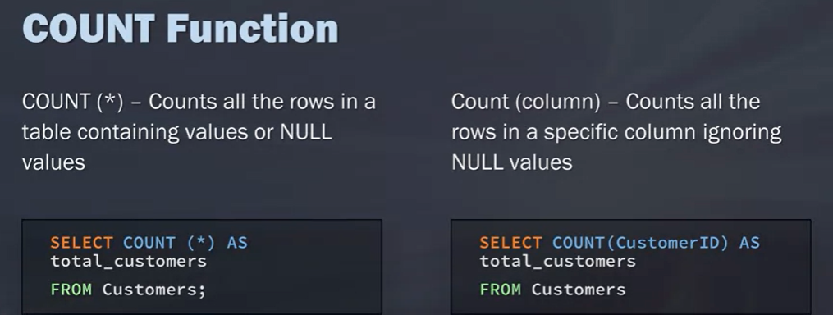

***
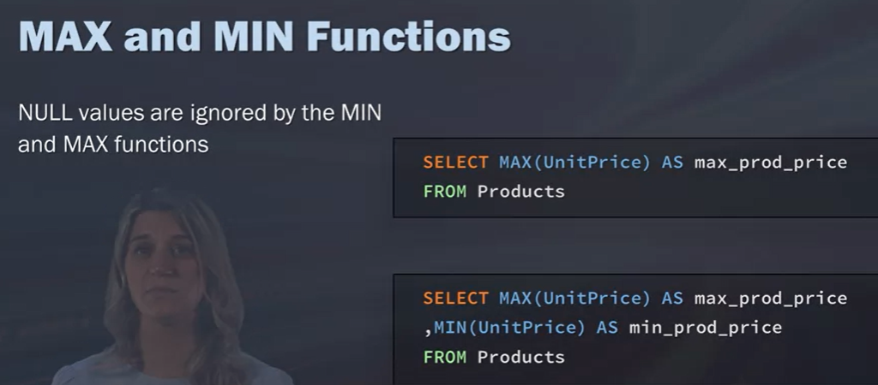

***

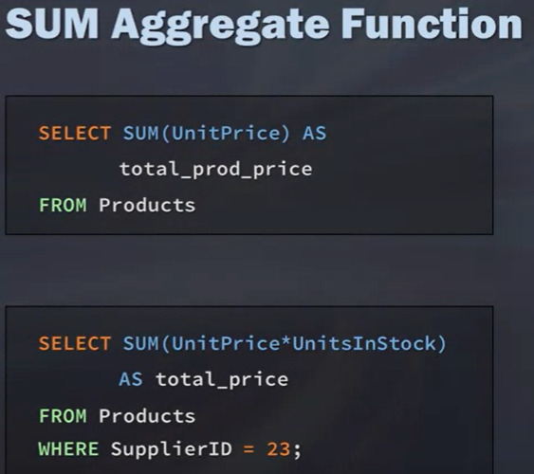

***

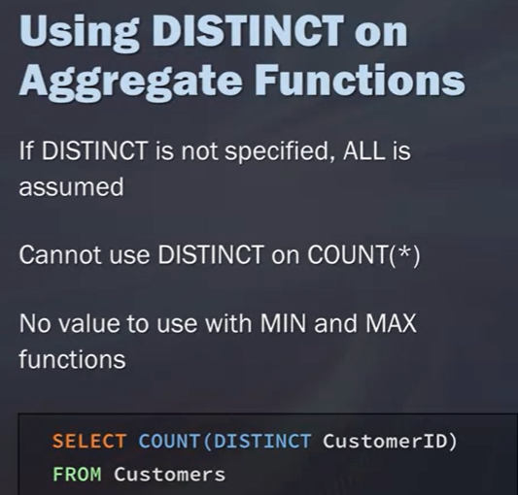

Grouping Data

GROUP BY
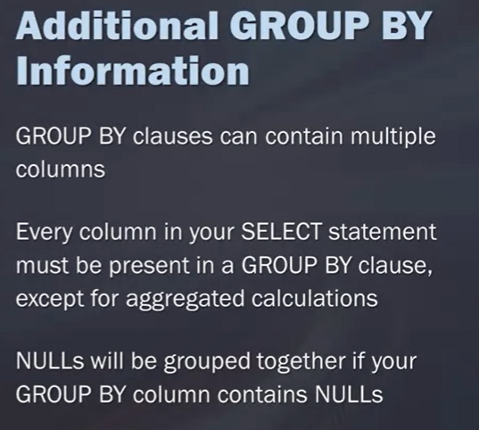
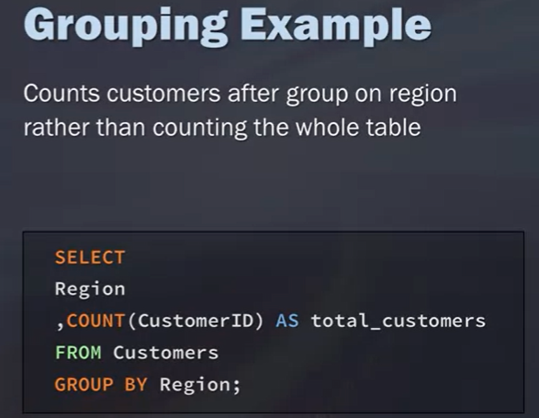

HAVING
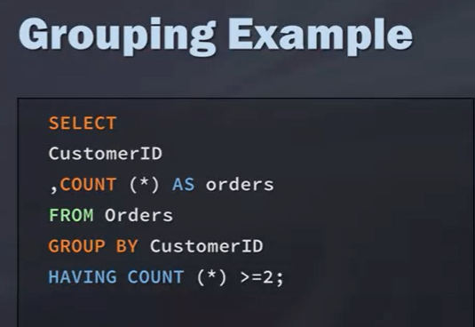
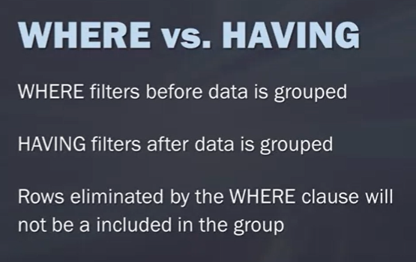

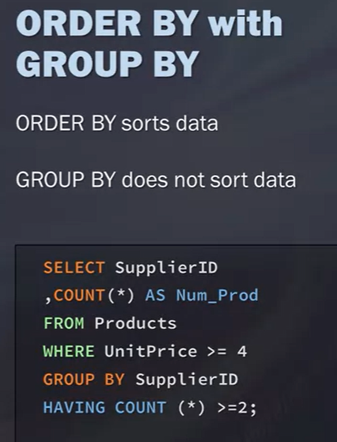

****
Sorulardan...

Show the number of orders placed by each customer (hint: this is found in the invoices table) and sort the result by the number of orders in descending order.

select CustomerId ,
COUNT(InvoiceId)
from Invoices
group by CustomerId
order by COUNT(InvoiceId) DESC

Çıktısı
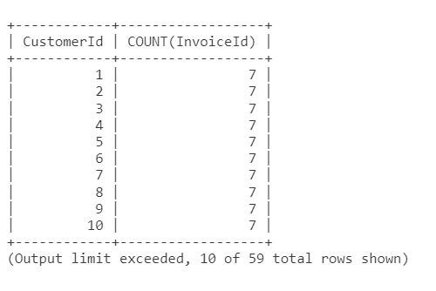

SUBQUERIES AND JOINS

Iki ayri tablodan bir sonuca ula;mak istersek

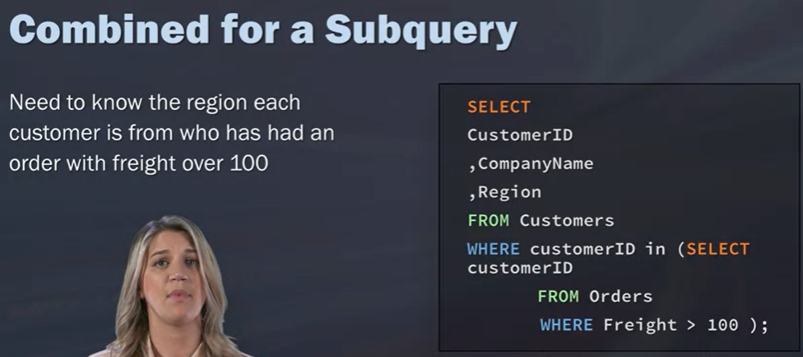
***

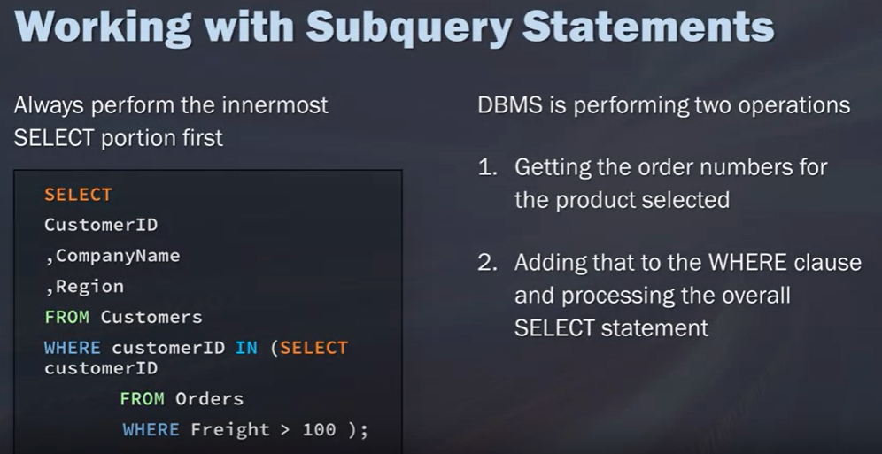

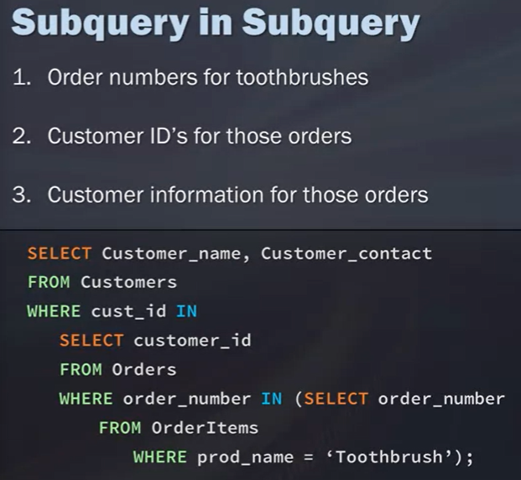
***İçiçe 3 tane query

***Iki ayrı table’da customer_id ortak sütunu üzerinden bağ kuruyoruz.

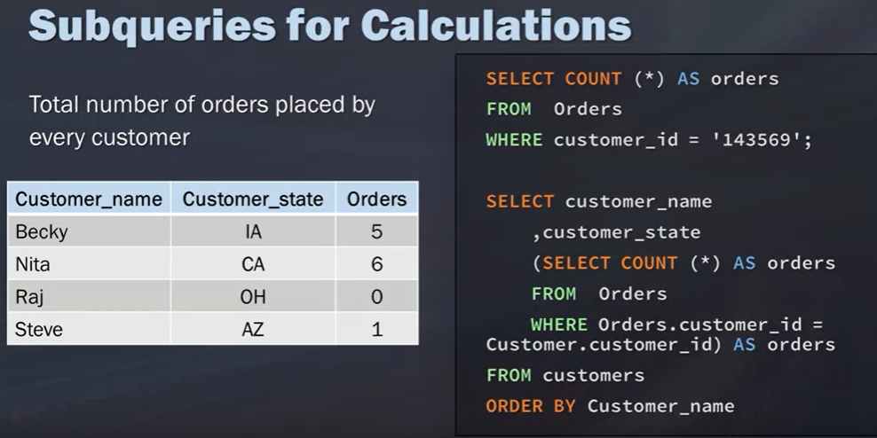

JOIN
Alternatif olarak farklı tablolardaki bilgiye ulaşmak için Join kullanabiliriz.

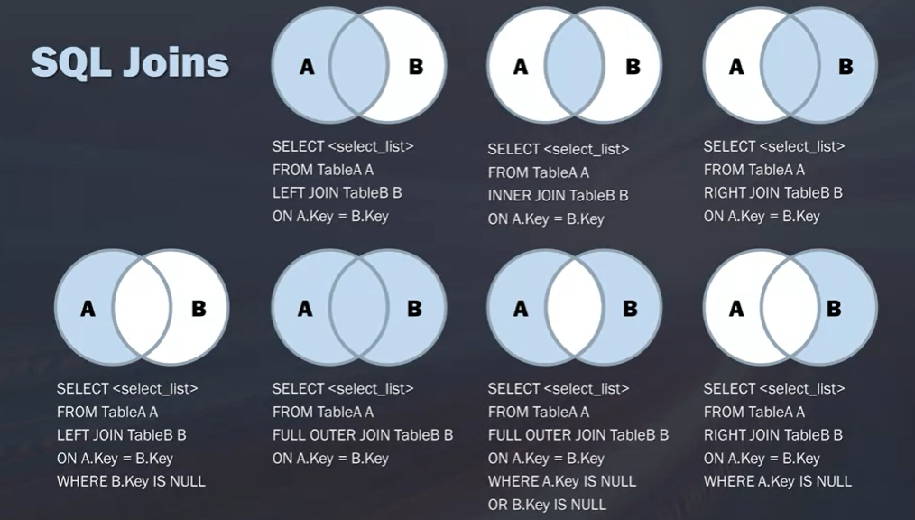

Neden farklı table’larda saklarız sorusunun cevabı.
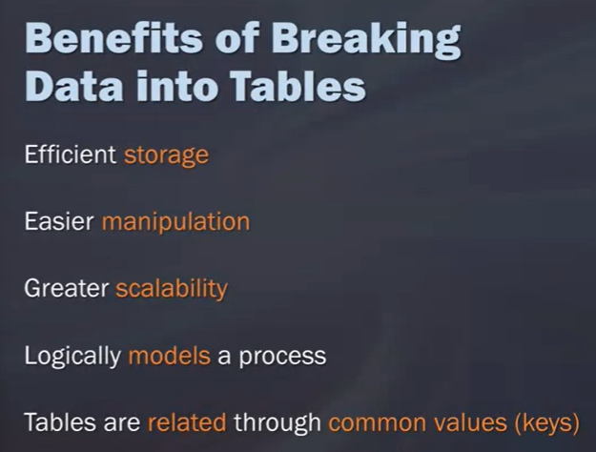

***
Cartesian (Cross) Join
A Cartesian Join allows you to take each record from the first table and match it with all of the rows from the second table.

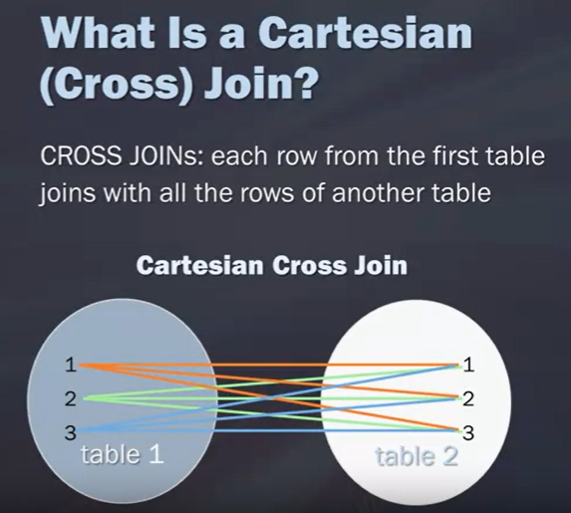
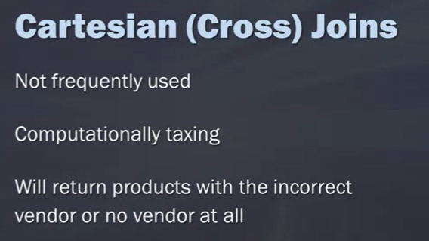

***

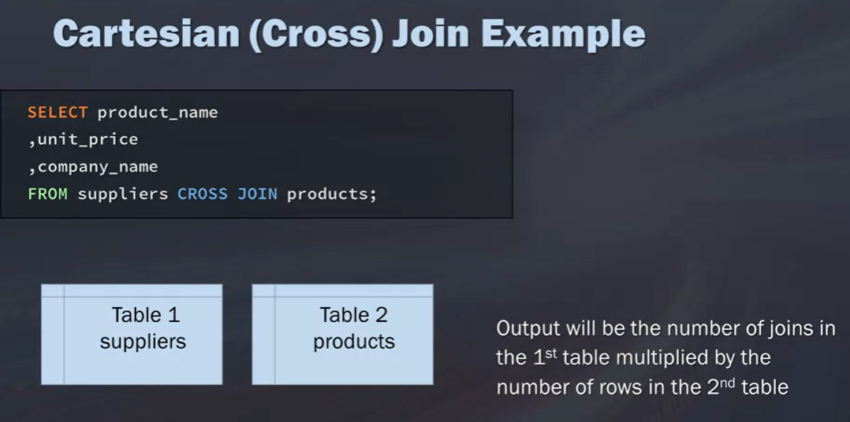

***
Inner Join
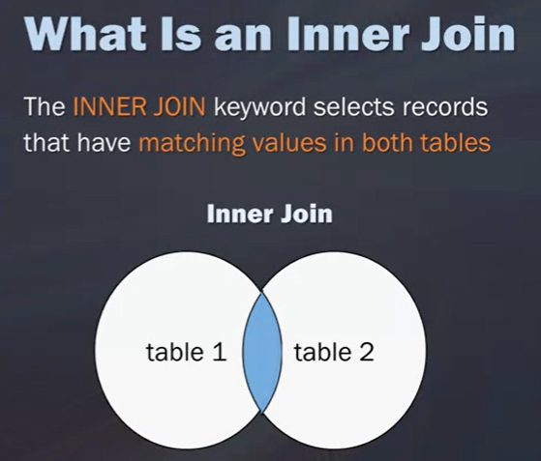
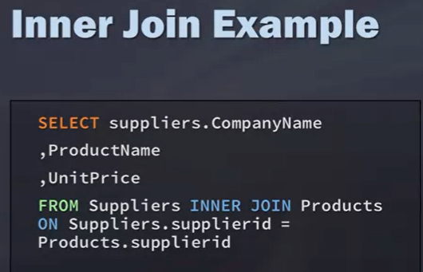

***

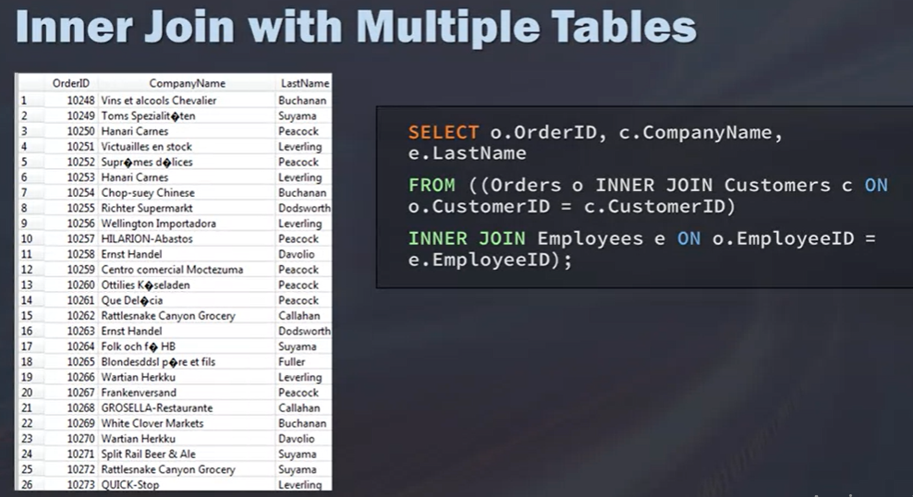

***
Use Alias
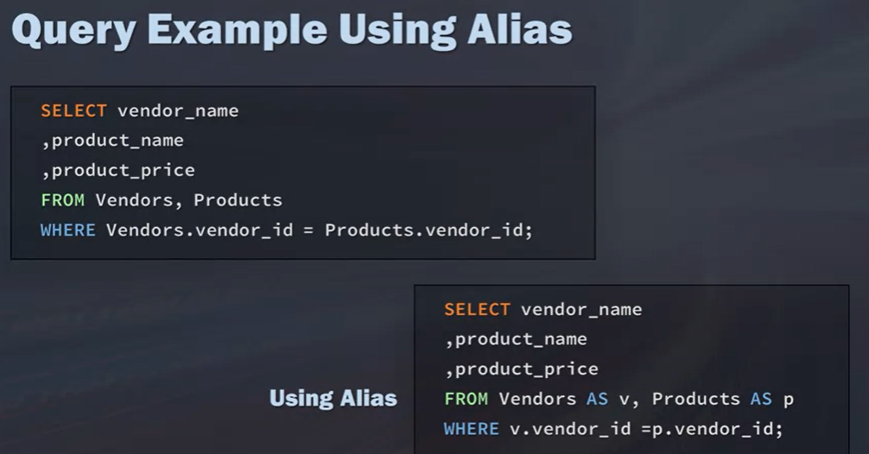

***
Self Join

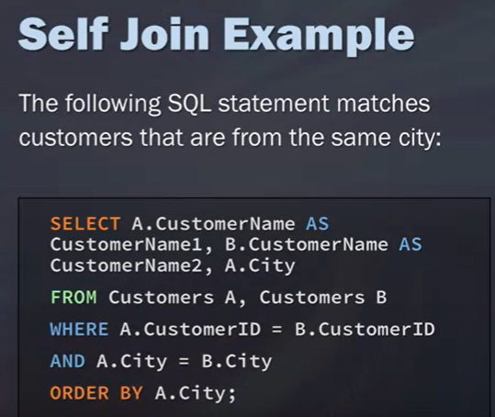

***

Left, Right and Full Outer Join

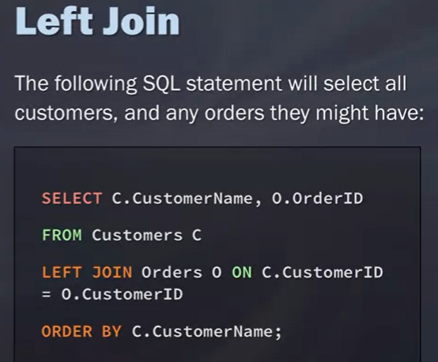
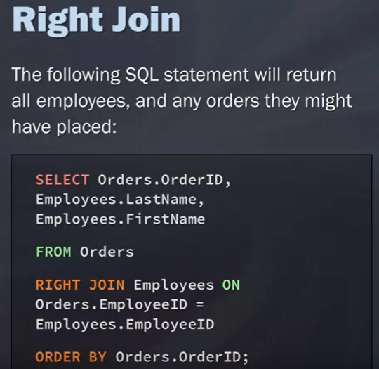

***
Right Join and Full Outer Join are not supported by SQLite

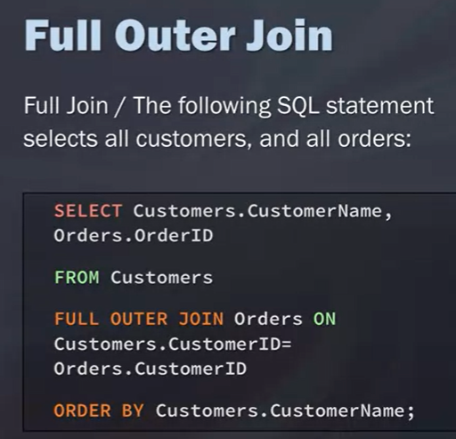

***
UNION

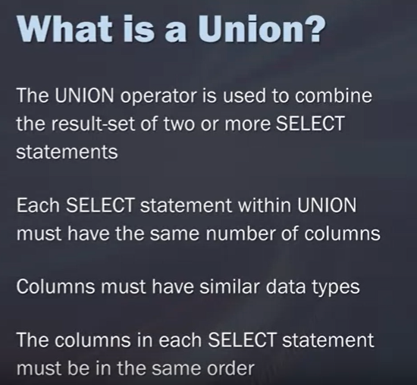

***

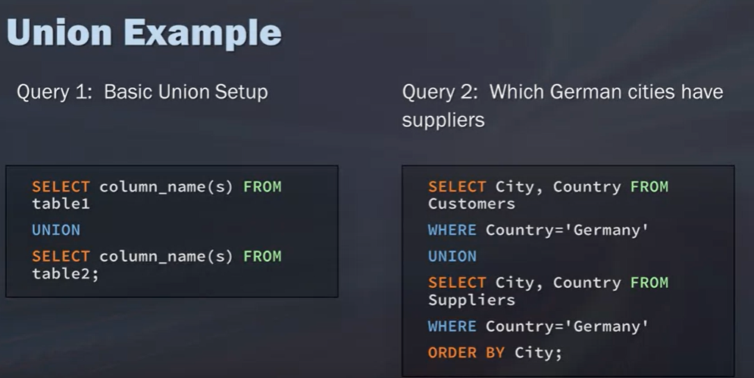

MODIFYING AND ANALYZING DATA

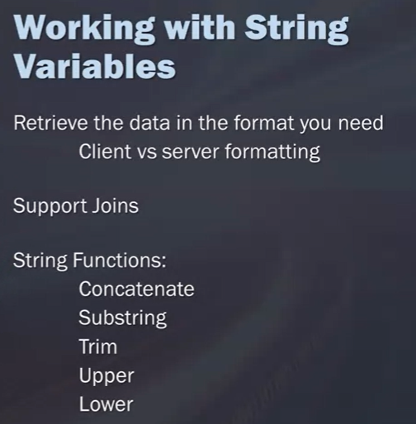

CONCATENATE

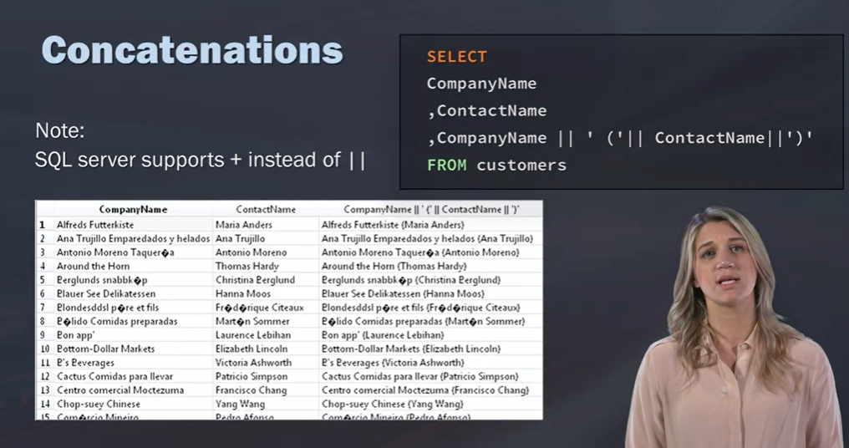

Sağ taraftaki çözümde ContactName’leri parantez içinde eklemiş.

TRIMMING

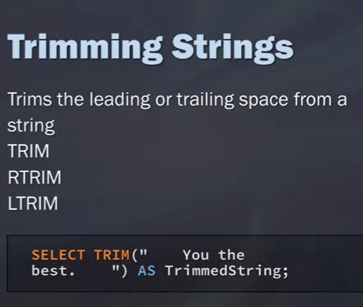

RTRIM (Right Trim), LTRIM(Left Trim)

***
SUBSTRING

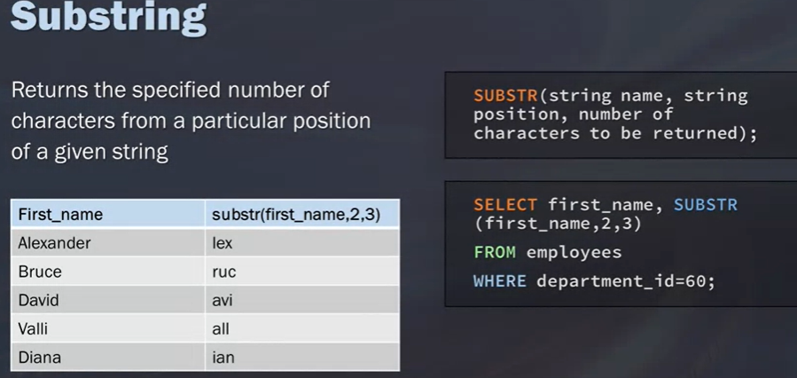

Yukarıdaki örnekte 2. sıradan başlayarak 3’er harf getir dedi.
Aşağıdaki örnekte ise 3. sıradan başlayıp 4’er tane getir diyoruz.
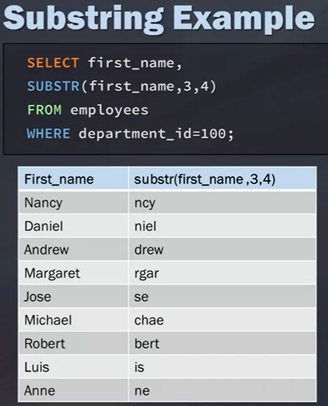

***
UPPER / LOWER / UCASE

You're going to say upper and then the column name that you want to change to uppercase. An alternative function that does the same thing is UCASE. Then, to convert strings to lowercase, you can use the function, LOWER.

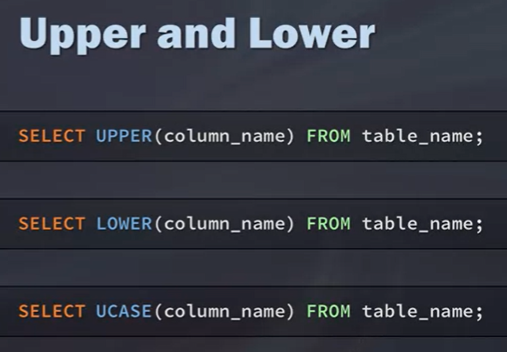

DATE AND TIME STRINGS

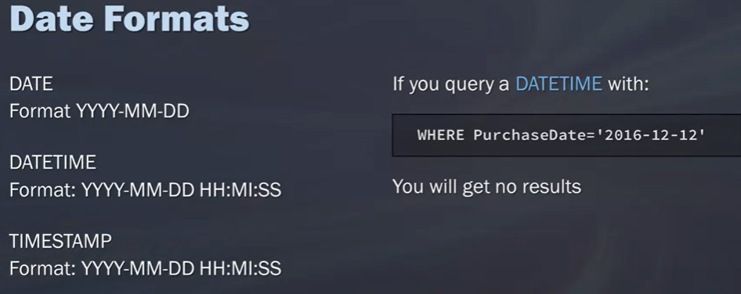

***

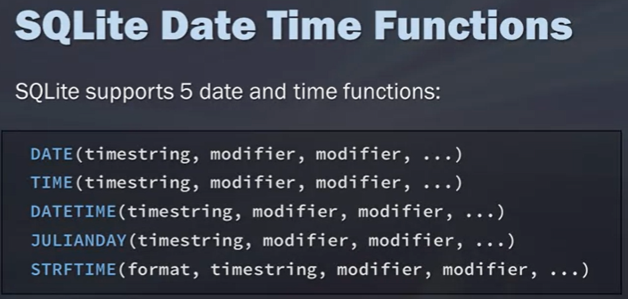

***
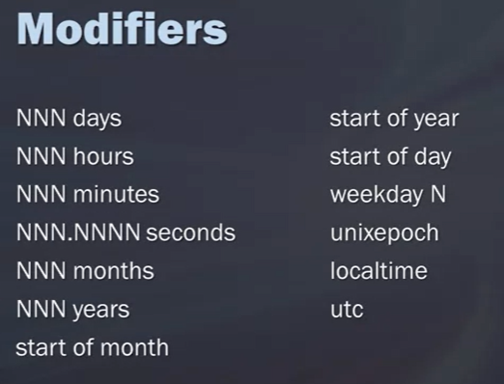

***

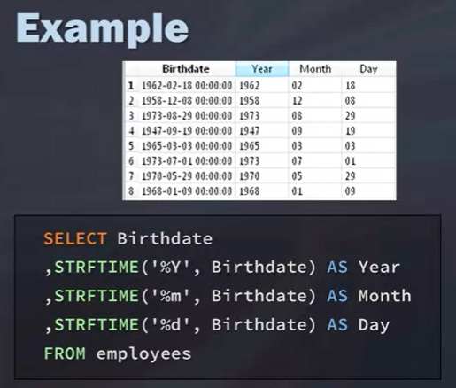

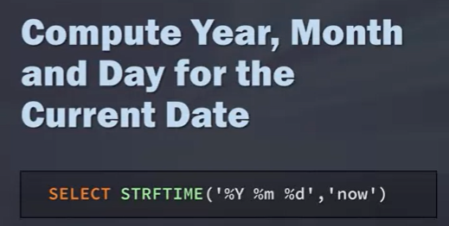
***
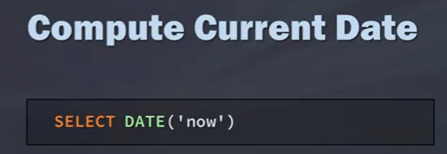

***
Eğer güncel yaşı öğrenmek istersek aşağıdaki gibi yazabiliriz.

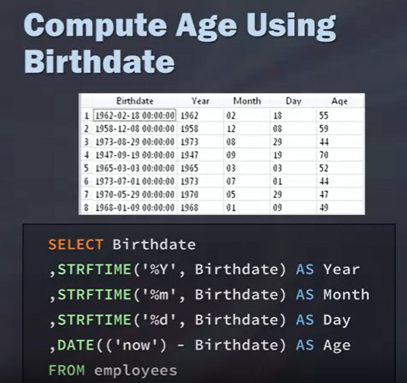

***

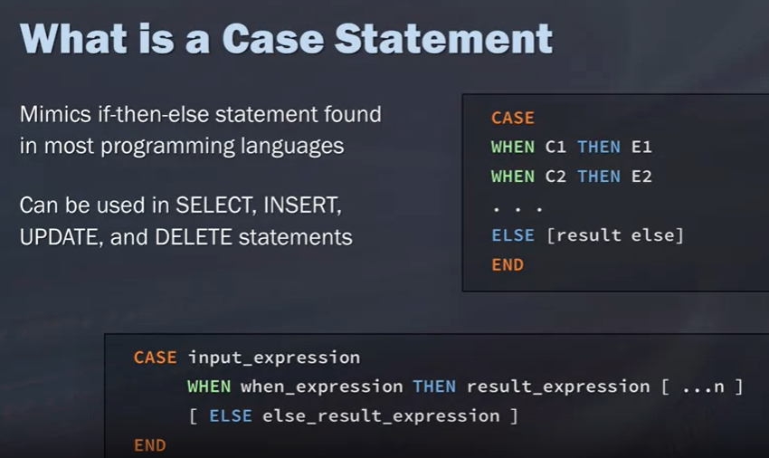

***

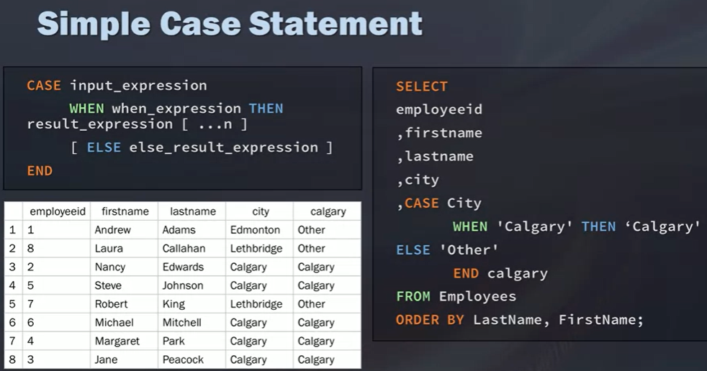

***

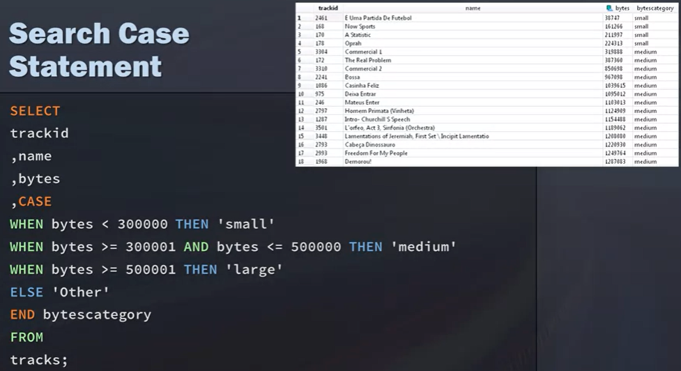

***

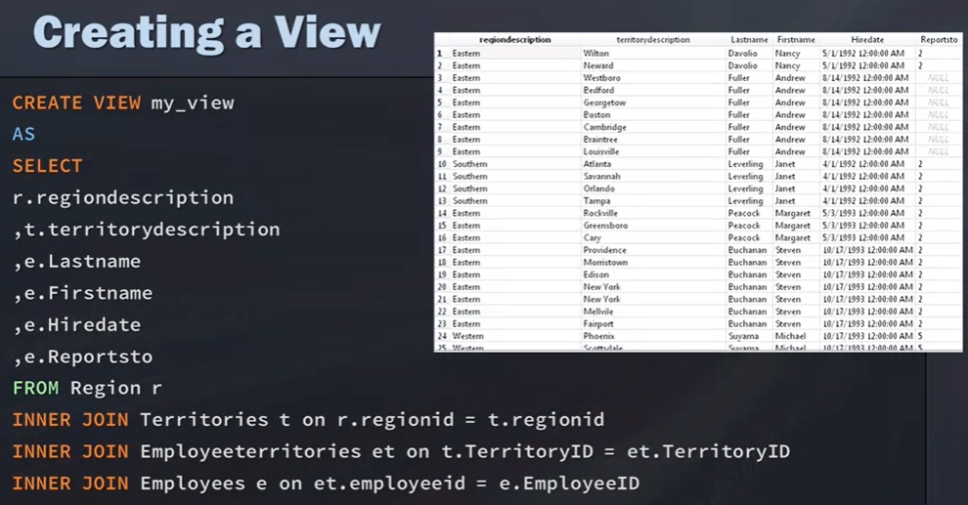

View’i Düşürmek için
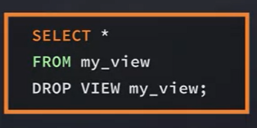

***
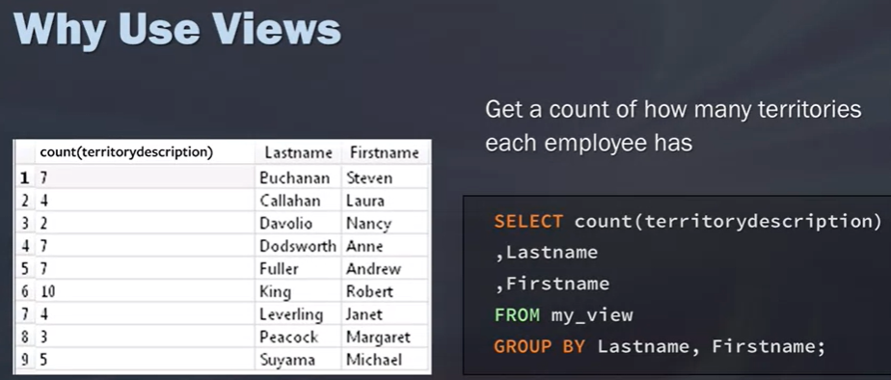

---------------------------------

NOTE: In MySQL we can save data to addtional place with “savepoint” . We can give a name after savepoint code. This code is written afer the data in our table. For example at the end of the İnserts. In case of deleting data, we can call it back with “role back”. Let’s consşder we name it

Inser into ....values(...)
savepoint ABC;

Then we can call it back

roleback to ABC;

